 

**Texas College of Management & IT**

**Bachelor of Information Technology (BIT)**

**Project Title:** Creating a Web Page Using HTML and CSS with

Integrated Analytical Understanding of Internet Applications

**Submitted By:**

Name: Anuraj Gautam

LCID: LC00017003334

Semester: 2nd Semester, 1st Year

**Submitted To:**

Instructor Name: Durga Nand Panjiyar

Course: IFA

Date of Submission: 2025/7/

Texas College of Management &IT, Kathmandu

**Table of Content**

1.Case Study 1……………………………………………. 3-5

1. Issues in Connect IPS
2. Fraudulent Behavior
3. Trust Issues
4. Scalability Problems
5. Solution to Improve Connect IPS
6. Fraud prevention
7. Dispute resolution
8. Rating & Review System
9. Recommendation for Platform Scaling and Performance Improvement

1.Performance Enhancements

2. Infrastructure Scaling

3. Backend improvements

4. Database performance

2. E-commerce Challenges: Shopping Cart Abandonment……………………………… 5

- Psychological Factors

-Technical factors

-Solutions Using AI-Driven Smart Checkout

3.Creating a Dynamic Responsive Three-Column Layout………………………………. 6

-CSS Grid vs Flexbox

-Advantages

-Sample CSS code Snippet

4. Mini project …………………………………………………………………………. 7-13

5. Conclusion &Reference………………………………………………………………14

6.Declaration of Originality…………………………………………………………….. 15

Case Study 1

A.

Connect IPS, being an online freelancing marketplace, is also suffering significantly from fraudulent behavior, trust, and scalability issues, which are consequently affecting user satisfaction and platform growth.

The issue of fraudulent activity has been on the rise because of some fundamental design flaws in the platform. One significant root cause is that there is no identity verification for clients and freelancers alike. With no proper KYC (Know Your Customer) procedures, anyone can register and post jobs or take on work without being accountable. There is also no escrow or payment guarantee system. This allows freelancers to finish a project and still not receive payment if the client chooses to vanish or contest the work. Another enabling factor is the platform's lax content moderation that enables fake or deceptive job listings to go live without adequate filtering, making honest freelancers’ easier prey for scammers.

On the issue of trust, freelancers are most concerned with the platform’s reliability and fairness. This issue stems mostly from the fact that there is no reputation or overview system for clients. Unlike sites where feedback from other users guides future interaction, Connect IPS does not offer sufficient information on previews behavior or experience with user. Additionally, there is no official dispute resolution process, so when issues occur such as disputes over project quality or pay—there is no formal mechanism to help resolve them. This leaves freelancers feeling exposed and unsupported. Further, the general lack of transparency regarding how projects are handled, or payments are processed contributes to user frustration, as they are unsure of the protections and policies the platform has in place.

Lastly, the problem of platform scalability is also getting worse with the increasing user base. The primary reason is an ineffective backend architecture that isn't meant for handling a high number of concurrent users. Therefore, users face slow load times and system crashes at peak times. This is compounded by inefficient database optimization and a lack of caching mechanisms, so each request strains the database, further reducing performance. Furthermore, the platform might be on limited or old hosting infrastructure, which lacks automatic scaling to handle high loads. Unless the platform is upgraded to a newer, cloud-based environment, it will keep suffering from performance problems as it expands.

B. To improve security and trust on Connect IPS, three key components as below.

1.Fraud prevention: Connect IPS should strong identify verification through KYC process for both freelances and clients. This helps confirm that users are real and trustworthy. An escrow payment system should be to hold client funds securely until the freelancers completes the work and it is approved. AI-based fraud detection can be used to automatically monitor and flag suspicious activity, such as fake job posts or unusual behavior.

2. Dispute Resolution: To manage disputes in a justifiable way, the platform should have a dispute resolution system with a ticketing portal where users can raise complaints. The disputes must be reviewed by a team of support officers or trained staff based on platform policies and project history. There must be well-defined procedures for payment releases, cancellations, and timelines so that there is transparency and efficiency in the process.

3. Rating & Review System: A two-way rating and review system is necessary where both freelancers and clients can rate each other after the completion of a project. The reviews should be made publicly available on user profiles so future users can make intelligent decisions. To make the system equitable, weighted scoring can be used where greater emphasis is placed on more recent verified reviews, and the impact of older or potentially biased reviews is reduced.

C. I would like to recommend scaling the platform and improving its performance as the user base grows as below.

1. Performance Enhancement: Performance Enhancements To increase speed, caching mechanisms such as Redis or Memcached must be employed to hold often-retrieved data and alleviate the load on the database. CDNs (Content Delivery Networks) can also deliver static content such as images and CSS from servers that are closer to users for quicker load times.

2. Infrastructure Scaling: Scaling Infrastructure Deploying the platform on cloud providers like AWS, Azure, or Google Cloud allows for auto-scaling, where server resources are scaled automatically in response to traffic. Deploying Docker containers and Kubernetes orchestration provides seamless deployment, simple maintenance, and predictable app performance in every environment.

3. Backend improvements: To be scalable, Connect IPS must adopt a microservices architecture so that each service (payments, jobs, messaging, etc.) can be scaled independently. Using load balancers such as NGINX or AWS Elastic Load Balancer will distribute user traffic evenly across servers, and overload and downtime will be unlikely.

4. Database performance improvement: To optimize database performance is the direction to take in order to handle enormous user data. Indexed queries, partitioning, and read replicas will all speed up access and reduce query time. For unstructured data like chat or reviews, a transition to a NoSQL database (for instance, MongoDB) offers better flexibility and performance.

2. One of the most common challenges faced by e-commerce businesses is the high rate of shopping cart abandonment where customers add items to their cart but leave the site before completing the purchase. This issue is influenced by both psychological and technical factors. Psychologically, many users treat online shopping as a form of browsing or “window shopping” with no firm intent to buy, Others abandon their carts due to unexpected c costs, lack of trust or unclear return policies. The absence of urgency or emotional triggers can also cause users to postpone or forget the purchase entirely. From a technical perspective, slow website performance complicated checkout process, forced account creation, and lack of preferred payment method all contribute to frustration and abandonment.

To address these challenges, e-commerce platforms must adopt a strategy that combines personalization, trust -building, and convenience. One innovative solution is to use an AI-driven smart checkout system that adapt in real time to each user. For Example, based on browsing behavior, the system can show dynamic discount, offer free shopping pop-ups, or display low-stack alert to create urgency. Further, one-click checkout, guest checkout options, and acceptance of multiple payment gateways (including mobile wallets and buy-now-pay-later options) can minimize friction considerably. Cart reminder emails or push notifications with product images, discounts, or limited period offers can also be sent to users to bring them back and complete the purchase. By streamlining the checkout experience to be faster, quicker, and emotionally appealing, online stores can drastically cut down abandonment rates and improve conversion.

3. To create a dynamic, responsive three-column layout without using CSS frameworks, the best modern approach is using CSS Grid or Flexbox. Both are powerful layout tools in CSS, but for three-column structure that needs to automatically adapt to different screen sizes, CSS Grid offers more control and simplicity. CSS Grid allows developers to create layouts that work in both rows and columns, making it ideal for multi-directional layouts like content blocks, portfolios or dashboards. One of the advantages of grid is clean and centralized code structure.

Advantages of CSS Grid

1. Two-dimensional: CSS grid allows to manage both row and columns simultaneously, making it perfect for complex layout. Eg: Galleries
2. Cleaner code: the grid layout is defined centrally in container, making code more organized easier to read and easier to maintain.
3. Modern browser support: CSS grid is supported by all major modern browsers like Chrome, Firefox, Safari etc.

Code

.container {

display: grid ;

display: flex;

flex-wrap: wrap;

grid -template-columns: repeat (3, 1fr) ;

gap:20px;

}

Mini project

Html & CSS

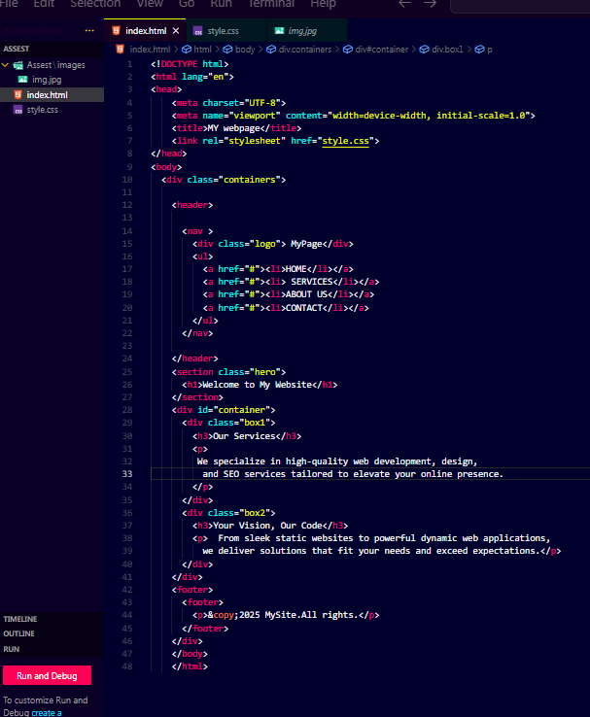

Output:

Phone: iPhone12 pro



PC:





Conclusion:

Connect IPS and e-commerce platforms face issues due to lack of trust, security and poor scalability. Implementing identity verification and review mechanisms can greatly enhance platform reliability. Upgrading backend Infrastructure and cloud -based solutions ensures better performance and scalability using modern CSS layouts like Grid improve responsiveness and use experience. Lastly mini project using grid, responsive all smart devices.

Reference:

This project is based on personal analysis and understanding of real-world platform challenges related to trust, fraud prevention scalability and user experience. For technical concepts and implementation resources, such as W3school were used for CSS grid layout guidance.

Declaration of Originality

I, Anuraj Gautam, declared that this mini project is my original work and that all references have been appropriately cited.

**Signature:**

Date: 2025-07-18